DS 413/613 HOMEWORK 3 Chapter 16 Vectors , Lists , and Functions

Vector1 <- (c( 10, 19, 121, 83, 63, 7, 77, 61, 51, 97, 123, 41))

Vector1

1) For the vector given above, use and show **two methods** of R coding to extract the first element and the last element.

2) For the vector given above, use and show **two methods** of R coding to extract all of the elements that are less than 60.

3) For the vector given above, use and show **two methods** of R coding to extract all numbers that are not divisible by 2 or 3.

4) Use and show **two R coding** **methods** to confirm that Vector1 does not have missing values

myList <- list(TRUE, 12.35, “pear”, 48, c = 3:8, list(23, “team”))

myList

(note: it is better to type the list into R studio or R markdown. Do not copy and paste)

Use the list above for problems 4 – 6.

5) For the list given above, use and show R coding to confirm that “pear” is a character element.

6) For the list given above, use and show R coding to extract the first three elements of the list.

7) Use the $ operator to extract the element “pear” from your list. Be sure to use and show required R code to produce the requested output.

8) Use and show R code to **write a function** to solve the following quadratic equations by using the **quadratic formula.** (all equations have two real number solutions)

a) x2- 3x - 28 = 0 b) x2 + x - 30 = 0 c) 3x2+ 14x + 8 = 0 d) 2x2+11x = 6

9) In your book (towards the end of chapter 16) a special set of vectors are defined as Augmented Vectors. One such augmented vector is a **Tibble**. Use and show R code that will produce the Tibble shown below. Do not simply type or copy and paste. You must show and use R coding that will output the tibble.

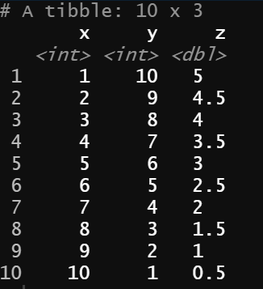

10) In statistics, the Interquartile Range is the difference between Q3 and Q1. Now show and use **map function** coding to find the **Interquartile Range** for each column of the tibble from number 9.